Along-Path Propagation Measurements

for the

4 April 2024 Total Solar Eclipse

David Kazdan

29 August 2023

All of the HamSCI efforts to date in eclipse propagation measurement use signals sent from WWV in Colorado to receivers *across* the path of the eclipse from WWV.  We consider here testing *along* the eclipse path.

For that *across path* propagation, WWV’s location north of Denver puts one-hop signals that reflect from the eclipse path along the southeast Atlantic coast of the US.  Two-hop signals with eclipse path reflection land farther inland after their second hop; Atlanta is a predictable point.  The first earth strike of two hop signals are between WWV and the eclipse path and should not be affected by the eclipse.

Here is the eclipse path in two different map projections:

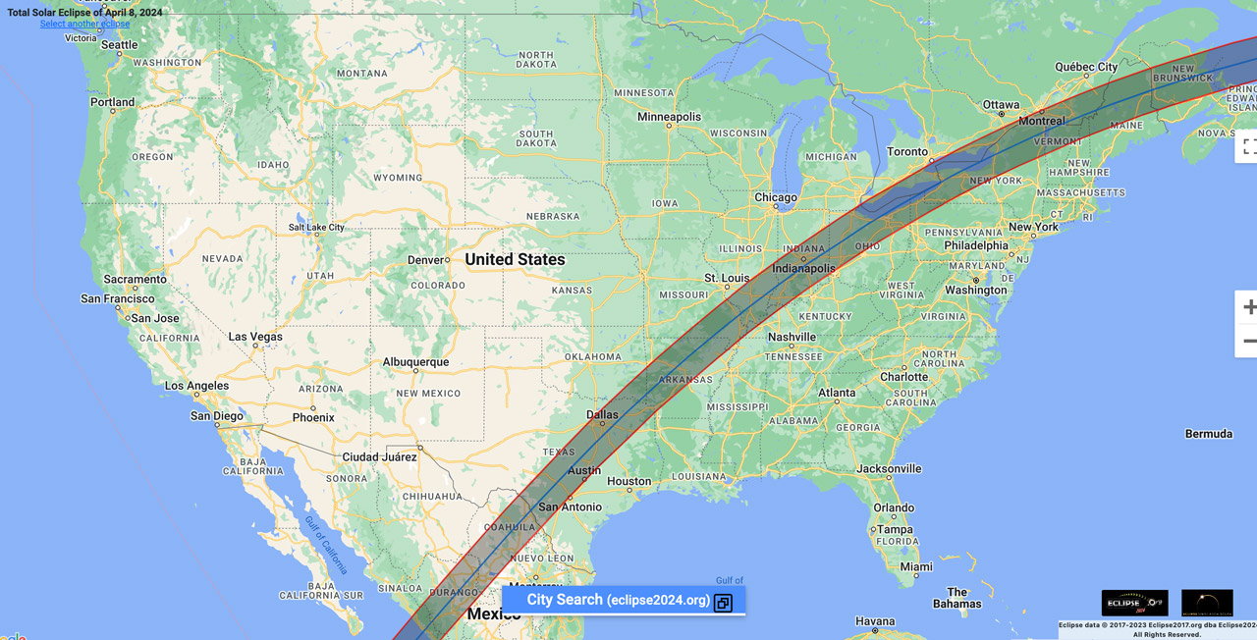

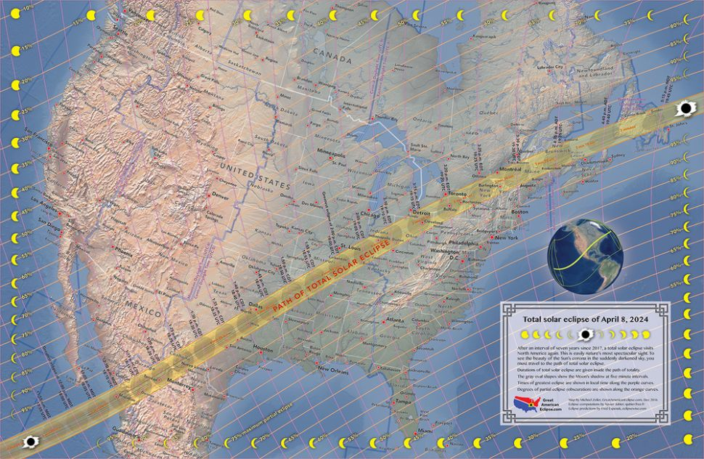

*Along-path* propagation is different and may also be worth studying.  Note that *by coincidence*, the portion of the eclipse path from Cleveland into Texas approximates the great circle path that a radio signal would follow.  The great circle path is shown in this map as it stretches from Cleveland to Austin:

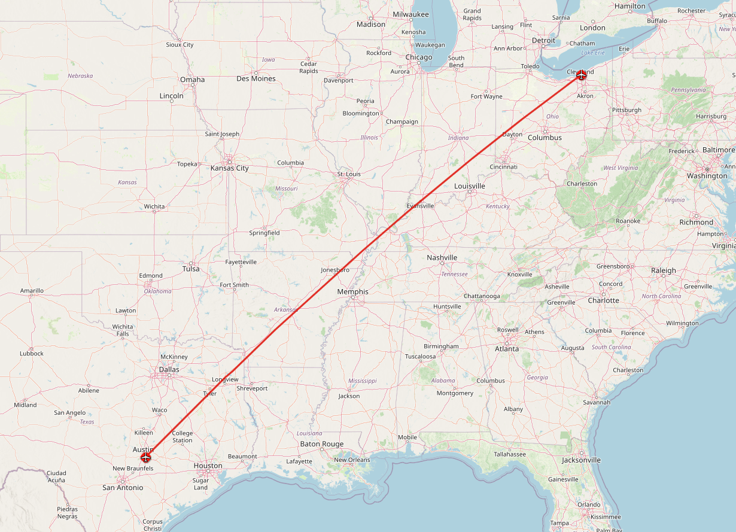

The coincidence of the two paths (eclipse and great-circle) suggests that a different propagation experiment might be done that involves a beacon transmitter at one extreme of this path, say Cleveland, and a receiver at the other.  Received signal amplitude may vary as parts of the ionosphere are blocked from sunlight by the moon’s shadow, and it may be possible to elucidate a pattern of skips, say single, double, and triple hop.

The simplest experiment that might be features a continuous-wave transmitter at one side and a receiver recording signal strength at the other.  The current WWV monitoring uses a variant on fldigi’s frequency monitoring modem to accomplish this, and a signal sent from W8EDU with periodic Morse or voice identification could be used.  The Doppler shift information so collected could be of use the same way that the WWV monitoring has been.  This measurement does require accurate frequency of the transmitted signal and an accurate timebase on the receiver.  We have been accomplishing that with GPS controlled oscillators on the receivers; WWV is already frequency accurate.  The data collection system, usually a microcomputer with a USB sound card pressed into service as the analog to digital converter, is kept timed by internet timing.  Its timing is not as critical as the frequency.

An alternative is examining transmitted sideband information.  WWV sends a full-carrier AM signal with several “radar of opportunity” modulations.  The second tick, consisting of five cycles of 1000 Hz sent at the beginning of most UTC seconds, provides a convenient pattern:

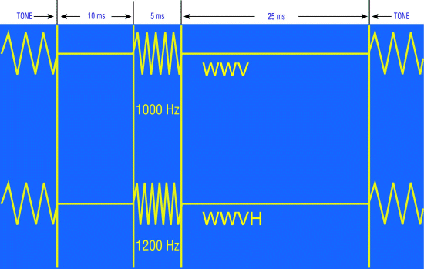

We have recorded several years of that tick, mostly on 25 MHz, and shown that time of flight and signal intensity are readily displayed.  The second ticks are sent with 100% modulation and may be received with an AM receiver that is not frequency-precise.  The data collection has been by a microcontroller’s analog-to-digital converter running about ten milliseconds into each second, started by a GPS receiver’s pulse-per-second leading edge.

The station might be sent within regulations on amateur bands with a Morse ID at least every ten minutes.

Coherent CW is a more complicated possibility.  It would have the promise of being more sensitive than the second ticks but would require more software development going into the eclipse.

Choice of frequency is another issue.  If we can only run one transmitter, the 30 meter amateur band may predictably offer the best signal variations.  If several transmitter-receiver pairs could be run, it would be interesting to include 80 meters; that band would not be expected to provide signal from Cleveland to Austin during the day at amateur power levels, but if the D layer is disrupted by the moon’s shadow, perhaps it would for brief times.

Another possibility:  Use the Canadian time-frequency standard station CHU-Canada, in Ottawa, Ontario.  Here is the great-circle map of Ottawa to Austin:

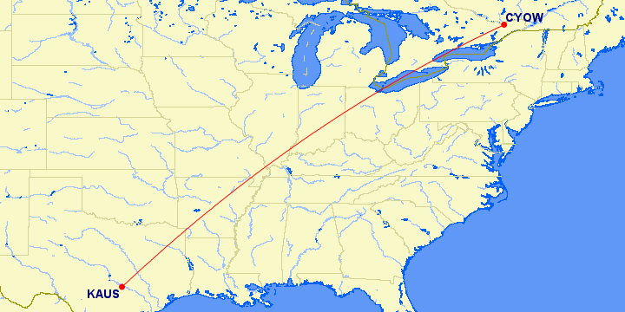

CHU transits signals that are roughly similar to WWV’s.  The [format of the second ticks](https://en.wikipedia.org/wiki/CHU_(radio_station)#Time_signal_format) is slightly different from WWV’s but the existing second tick recording system could be modified to accommodate that.

The Grape II receiver system with its Raspberry Pi amplitude and frequency measurement is set up to receive the three CHU signals simultaneously, so that is another possibility.

|  |  |  |
| --- | --- | --- |
| Signal method comparisons for along-path eclipse testing. |  |  |
| **Modulation type** | **Pros** | **Cons** |
| Steady carrier only, ID by on/off telegraphy | * Simple to implement transmit control: Arduino with keying transistor to transmitter key input. * Needs Morse ID, which is easy to implement with Arduino. * Maximum signal power transmitted. * Use current fldigi data recording methods | * Requires frequency-disciplined receiver. * Gives only relative time of flight information through Doppler shift. * Doesn’t give as definite a null as some other methods–hard to know if signal is absent. |
| WWV-style with second ticks on AM | * Alternative method of determining signal amplitude and time of flight. * Because time of flight is absolute, comparison of different stations’ receptions is facilitated. * Can use simple receivers with AM detector, no frequency discipline. | * Data collection microcontroller requires GPS control. * Different method from currently implemented WWV Doppler |
| Digital signal | * Use error rate as measure of propagation. * Permits easier notification of amateur radio community why the signal is there, maybe get less deliberate interference. * Need frequency discipline on neither transmitter nor receiver, just adequate stability. | * Would need more work to implement than other methods. * Possibly less total information obtained; would not get Doppler or time of flight information. |
| Coherent CW message | * Have much of the work already done, especially on the transmit side. * May be more palatable to amateur community to have CW on the air for several months rather than continuous carrier.. | * Longer total message for matched-filter decoding, so some information “smearing.” Something like “W8EDU ECLIPSE TEST” could run only about four times per minute at 24 WPM. * Will require considerable development and testing. |
| Use CHU | * Three frequencies at higher power than amateur, already available: 3.33, 7.85, 14.67 MHz. * Could use existing WWV second tick recording system with small modifications. * Would need GPS receiver on data collection board, not on receiver or host computer. * Alternatively, could use frequency-accurate receiver and use fldigi as we have been using for WWV. | * Highest frequency is 14.67 MHz; that may not matter. * The station signal path isn’t quite aligned with the longest stretch of eclipse great circle, but it’s close. * Grape II is planned to work with CHU, all three frequencies simultaneously. |